
Karingal Heights Primary School
Yard Duty and Supervision Policy 2026


Help for non-English speakers
If you need help to understand the information in this policy, please contact Karingal Heights Primary School office on 9789 3288.

Purpose
To ensure school staff understand their supervision and yard duty responsibilities.

Scope

This policy applies to all teaching and non-teaching staff at Karingal Heights Primary School including education support staff, casual relief teachers and visiting teachers.

Policy
Appropriate supervision is an important strategy to monitor student behaviour and enables staff to identify and respond to possible risks at school as they arise. It also plays a vital role in helping schools to discharge their duty of care to students.
The Principal is responsible for ensuring that there is a well organised and responsive system of supervision and yard duty in place during school hours, before and after school, and on school excursions and camps and other school activities.
School staff are responsible for following reasonable and lawful instructions from the Principal, including instructions to provide supervision to students at specific dates, times and places. Supervision should be undertaken in a way that identifies and mitigates risks to child safety.
Before and after school
Karingal Heights Primary School grounds are supervised by school staff from 8:45am until 3:30pm. Outside of these hours, school staff will not be available to supervise students.
School gates will open at 8:30am. Staff will supervise the senior and junior playground and basketball courts. All children are to leave the school grounds immediately once they are dismissed by their teacher at the end of the day. Junior children who do not ‘see their adult’ are to wait at the Havana oval gates with the supervising teacher.
Parents and carers will be advised through the school’s eNewsletter that they should not allow their children to attend Karingal Heights Primary School outside of these hours. Families will be encouraged to contact Camp Australia (based at Karingal Primary School) on 1300 105 343 for more information about the before and after school care facilities available to our school community.
If a student arrives at school before supervision commences at the beginning of the day, the Principal or nominee staff member will, as soon as practicable, follow up with the parent/carer to:
- advise of the supervision arrangements before school
- request that the parent/carer make alternate arrangements.
If a student is not collected before supervision finishes at the end of the day, the Principal or nominee staff member will consider whether it is appropriate to:
- attempt to contact the parents/carers
- attempt to contact the emergency contacts
- contact Victoria Police and/or Child Protection to arrange for the supervision, care and protection of the student.

Yard duty
All staff at Karingal Heights Primary School are expected to assist with yard duty supervision and will be included in the weekly roster.
The Principal or Wellbeing Coordinator is responsible for preparing and communicating the yard duty roster on a regular basis. Areas to supervise are the school oval, junior and senior playgrounds and asphalt areas. Areas such as those that are out of bounds and the toilets should be checked regularly.
Yard duty zones
The designated yard duty areas for our school as at term 1, 2026 are: Staff members on yard duty do not have designated zones but are expected to ‘roam’ all areas and make sure that they check the toilet areas regularly. Pink areas are out of bounds to students.
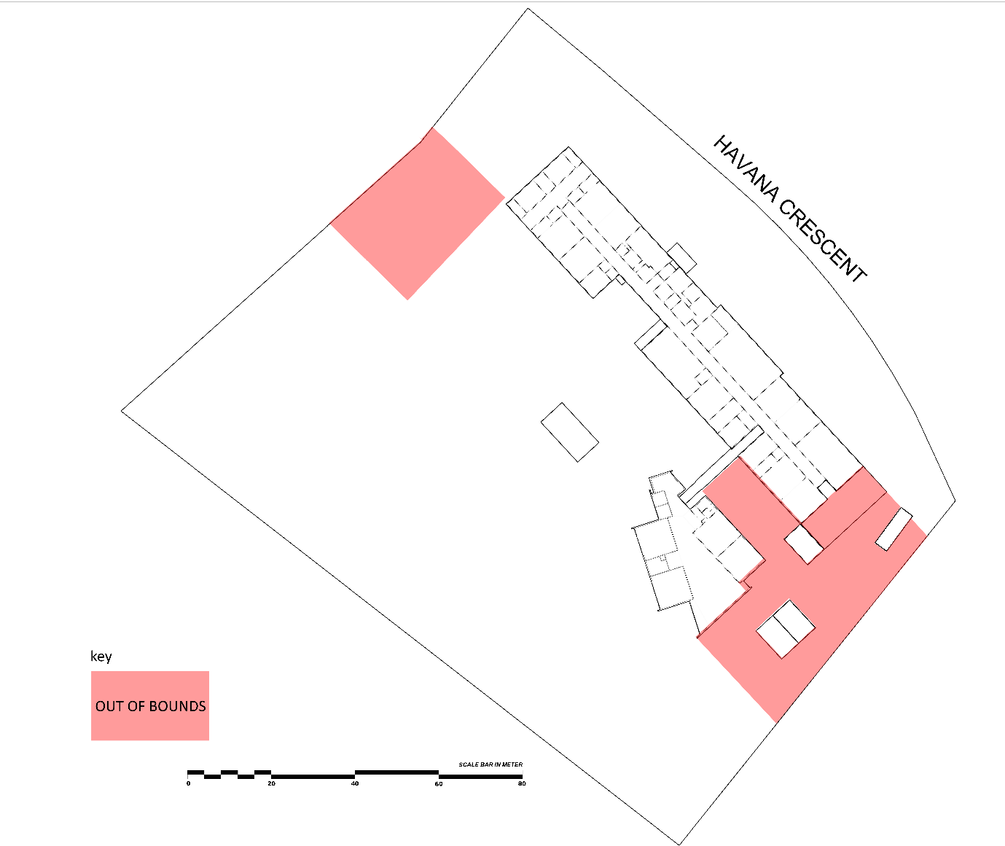

Yard duty equipment
School staff must:
- wear a provided safety/hi-vis vest whilst on yard duty. Safety/hi-vis vests will be stored in staff classrooms or pigeonholes.
Yard duty responsibilities
Staff who are rostered for yard duty must remain in the designated area until they are replaced by a relieving staff member.
During yard duty, supervising school staff must:
- methodically move around the designated zone ensuring active supervision of all students
- where safe to do so, approach any unknown visitor who is observed on school grounds without a clear legitimate purpose, and ensure they have a visitor pass and have signed in (excluding drop off and collection periods)
- ensure students in P-2 and 3-6 use the playground areas allocated to them and not of others.
- be alert and vigilant
- intervene immediately if potentially dangerous or inappropriate behaviour is observed in the yard
- enforce behavioural standards and implement appropriate consequences for breaches of safety rules, in accordance with any relevant disciplinary measures set out in the school’s School Wide Positive Behaviours matrix
- ensure that students who require first aid assistance receive it as soon as practicable
- log any incidents or near misses as appropriate on Sentral or report to the Principal or Wellbeing Coordinator.

If being relieved of their yard duty shift by another staff member (for example, where the shift is ‘split’ into 2 consecutive time periods), the staff member must ensure that a brief but adequate verbal ‘handover’ is given to the relieving staff member in relation to any issues which may have arisen during the first shift.
If the supervising staff member is unable to conduct yard duty at the designated time, they should contact the Principal with as much notice as possible prior to the relevant yard duty shift to ensure that alternative arrangements are made.
If the supervising staff member needs to leave yard duty during the allocated time, they should contact the Principal but should not leave the designated area until the relieving staff member has arrived in the designated area.
If the relieving staff member does not arrive for yard duty, the staff member currently on duty should send a message to the Principal and not leave the designated area until a relieving staff member has arrived.
Students will be encouraged to speak to the supervising yard duty staff member if they require assistance during recess or lunchtime.
Classroom
The classroom teacher is responsible for the supervision of all students in their care during class.
If a teacher needs to leave the classroom unattended at any time during a lesson, they should first contact the Principal or Wellbeing Coordinator for assistance. The teacher should then wait until a replacement staff member has arrived at the classroom before leaving.
School activities, camps and excursions
The Principal and leadership team are responsible for ensuring that students are appropriately supervised during all school activities, camps and excursions, including when external providers are engaged to conduct part or all of the activity. Appropriate supervision will be planned for school activities, camps and excursions on an individual basis, depending on the activities to be undertaken and the level of potential risk involved, and will follow the supervision requirements in the Department of Education and Training Excursions Policy.
Digital devices and virtual classroom
Karingal Heights Primary School follows the department’s Digital Technologies - Responsible Use policy with respect to supervision of students using digital devices. Karingal Heights Primary School will also ensure appropriate supervision of students participating in remote and flexible learning environments while on school site. In these cases, students will be supervised by a staff member either in their classroom or other appropriate learning area.
While parents are responsible for the appropriate supervision of students accessing virtual classrooms from home:
- student attendance will be monitored daily via Webex meetings or in the uploading of class work.
- any wellbeing or safety concerns for the student will be managed in accordance with our usual processes – refer to our Student Wellbeing and Engagement Policy and our Child abuse (including grooming) identification and response Policy for further information.
Students requiring additional supervision support
Sometimes students will require additional supervision, such as students with disability or other additional needs. In these cases, the Principal or delegate will ensure arrangements are made to roster additional staff as required. This may include on yard duty, in the classroom or during school activities.
Supervision of student in emergency operating environments
In emergency circumstances our school will follow our Emergency Management Plan, including with respect to supervision.
In the event of any mandatory period of remote or flexible learning our School will follow the operations guidance issued by the Department.
Other areas requiring supervision
Classes moving from one room to another will be supervised by a staff member.
Children using the toilets connected to the main building during class time will go in pairs.
COMMUNICATION

This policy will be communicated to our school community in the following ways:

- Included in staff induction processes
- Discussed at staff briefings or meetings, as required
- Included as a reference in our school newsletter
- Made available in hard copy from school administration upon request

Information for parents and students on supervision before and after school is available on our school website and parent reminders are periodically placed in our eNewsletter.

Further Information and Resources
- the Department’s Policy and Advisory Library (PAL):
  - Child Safe Standards
  - Digital Technologies - Responsible Use
  - Duty of Care
  - Excursions
  - Supervision of Students
  - Visitors in Schools

POLICY REVIEW AND APPROVAL

Policy last reviewed | June 2026
Approved by | Principal August 2026
Next scheduled review date | June 2028

This policy will also be updated if significant changes are made to school grounds that require a revision of Karingal Heights Primary School’s yard duty and supervision arrangements.

