Frida Kahlo

Frida was a Mexican artist. Her paintings and drawings were about her life. She loved vibrant colours. She loved to decorate and frame her paintings. In her own self portrait she exaggerated certain features, like joining her eyebrows together and adding a moustache. A bit like a caricature of herself.
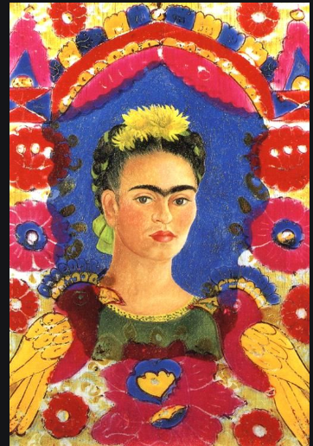
Draw a picture of yourself and add some things you are interested in and use these to make part of the frame around your self-portrait.

Remember what we have learned about drawing portraits. Make the shape of the face. Add in the “U”s to make the eyebrows and nose. Oval eyes.

