**TISSUE PAPER FLOWERS**

Last week, one of our on-site students Lilly, showed me a tissue paper flower she had made during her Zoom Girl Guide session. I thought it would be a great art activity, especially for ‘100 Days of School’ week. We are going to try to make 100 flowers to decorate the school.

If your child is finding this activity tricky, draw a big flower and scrunch up paper and paste onto the petals to decorate.

If you don’t have tissue paper, why not experiment and see what else you could use.

**Material:** 6 squares of tissue paper or more for a denser flower

A pipe cleaner or a hair pin

**Step** 1: Get 6 pieces of square tissue paper or any other coloured if you don’t have tissue paper.

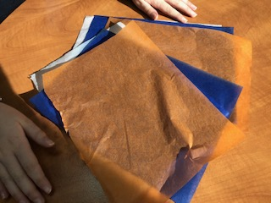

**Step 2:** Fold the tissue paper back and forth, the same way you would make a fan.

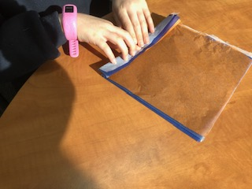

**Step 3**: Twist a pipe cleaner around the middle of the folds.

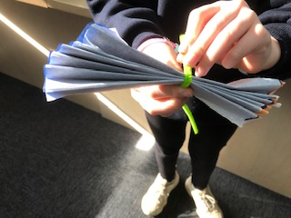

**Step 4:** Carefully pull apart of all the pieces of tissue paper to make your flower.

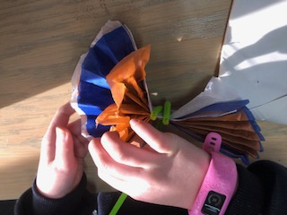

S**tep 5:** Arrange the petals nicely and then place in a vase.

