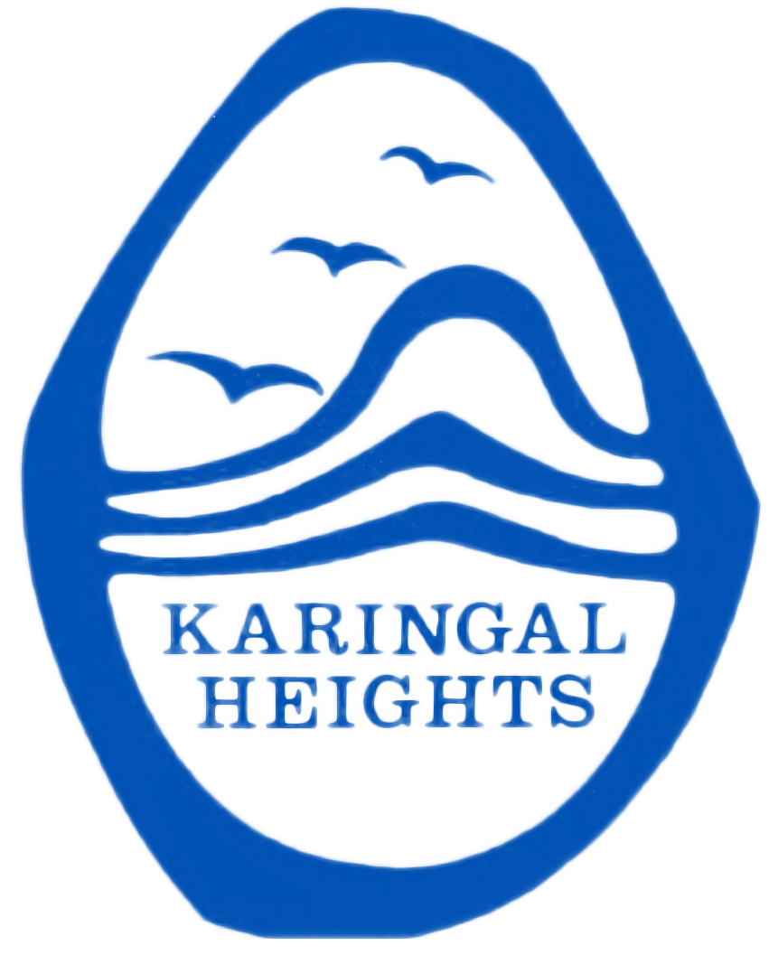
KARINGAL HEIGHTS PRIMARY SCHOOL

on-site attendance form
(2021)
Student/s name:
Student/s date of birth:
Student/s year level (P-10):
Victorian government schools will commence remote and flexible learning from 16 July 2021. | My child/ren will attend on-site learning as:  My child/ren is/are not able to be supervised at home and no other arrangements can be made as both parents/carers are authorised workers  OR  My child/ren is/are experiencing vulnerability.  OR  My child/ren has/ have a disability and cannot learn from home.  By submitting this form, I declare that my child/ren is/are well and I will collect my child/ren as soon as is practicable upon the request of the school if my child becomes unwell.
Dates required:  Please note you need to complete this process weekly to ensure adequate staffing onsite. | Day Date AM, PM or ALL DAY  Monday AM / PM / ALL DAY  Tuesday AM / PM / ALL DAY  Wednesday AM / PM / ALL DAY  Thursday AM / PM / ALL DAY  Friday AM / PM / ALL DAY
Emergency contact details: | Name:  Phone:  Relationship:
Parent/Guardian name:
Signature:
Date:

Children experiencing vulnerability include: - children in out-of-home care - children deemed vulnerable by a government agency, funded family or family violence service, and assessed as requiring education and care outside the family home - children identified by a school or early childhood service as vulnerable, (including via referral from a government agency, or funded family or family violence service, homeless or youth justice service or mental health or other health service) - Students with a disability who are vulnerable due to family stress
‘Disability’ refers to all students receiving adjustments, including (but not limited to) those supported through the Program for Students with Disabilities. Received and Processed by Kerryn Riley on (date)……………………………………

