Issue #4

Important Dates

November 7
Transition Session #5
Sit down with some of our current parents to ask the questions you really want to ask!

November 21
Transition Session #6.
Meet our Business Manager, Pauline Horton, and discuss fees and charges for 2019.
December 5
Transition Session #7
December 10
Prep Information Night @ 7pm
December 11
Orientation Day, 9.15 – 11.15am
Tues 30th January 2019
First day of Prep!

Prep Transition Newsletter
Dear Families,
Each transition session is carefully planned to slowly transition students from free play to more structured activities as they build more confidence within the school environment. Parents may have noticed that the last two sessions began with a shared book on the floor – we are progressively working up to more group time each session. Students also learned about how we pack up when we are at school. I had some excellent helpers this week!
We understand that there may be times when your child is unable to attend a transition session, however I encourage you to attend as many as you can. This consistency will allow your child to gradually build confidence and beginning school skills that will ease their transition at the beginning of their Prep year.
Let’s work together to ensure that your child has a successful and positive first year of schooling!
Nicole Longino
(Prep Teacher & Transition Coordinator)
School Phone: (03) 9789 3288
School Email: karingal.heights.ps@edumail.vic.gov.au
School Website: www.karingalheightsps.vic.edu.au
Prep Coordinator: longino.nicole.n@edumail.vic.gov.au

Exploring School Life
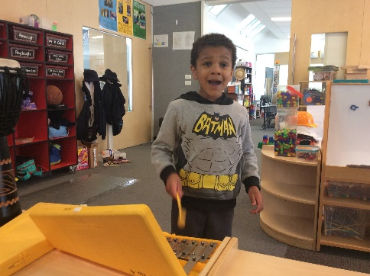

The Kissing Hand
During this week’s transition session we read a book called “The Kissing Hand” by Audrey Penn.
In the book, Chester Raccoon is scared about starting school. His mum places a kiss in the middle of his palm. Chester folds up his hand and knows that any time he misses home, he can press his hand to his cheek and his mum’s love will be there.
School can be an exciting and scary time for young children.
Consider making your own kissing hand with your child, or creating something personal for your family that will let your child know that they are ok and their family is always with them.

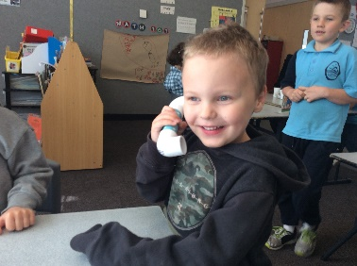
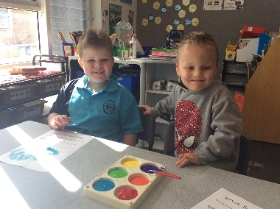
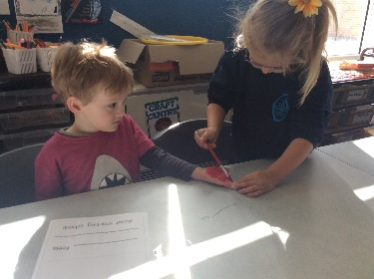
This week our activities centered around a more structured approach to activities. We began with a story called “The Kissing Hand”, which is a book about feelings that children may experience when they first start school. There was a follow up craft and writing activity, a fine motor number activity, textured writing (chalk) and a phonics phones activity.

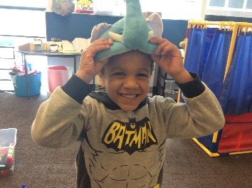
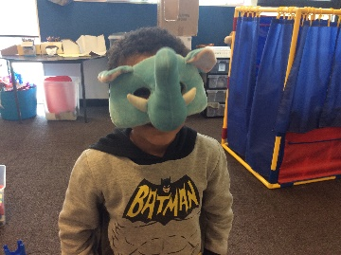
We also talked about how to pack things in their homes when we are finished with them and had a three minute practice – everyone did an excellent job! After this we spent some time practicing walking like ants outside (in a straight line) and explored our junior playground and sandpit.

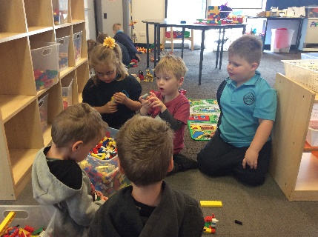
During our next session students will experience a short, structured lesson, from start to finish. They will listen to a story, complete an academic activity and will finish on the floor as a group. This time will help students

