Issue #1

Important Dates

October 12
Transition Session #2

October 26
Transition Session #3

November 9
Transition Session #4

November 23
Transition Session #5

December 7
Last Transition Session

Get our App!
Karingal Heights uses the Updat-ed App to communicate important information and events with the school community.
The app can be downloaded from the App Store (iPhone) or the Play Store (Android).

Prep Transition Newsletter
Dear Families,
Welcome to Karingal Heights Primary School! We are looking forward to having your family as part of our wonderful school community.
This Transition to School Newsletter contains information that will help both you and your child to settle into school life at Karingal Heights. Please take the time to read this important information.
If you have any questions regarding the school or the Prep year in general, let us know – we’re here to help!
Nicole Longino
(Prep Teacher & Transition Coordinator)
School Phone: (03) 9789 3288
School Email: karingal.heights.ps@edumail.vic.gov.au
School Website: www.karingalheightsps.vic.edu.au
Prep Coordinator: longino.nicole.n@edumail.vic.gov.au

Visit our current Prep’s class blog at:
http://minimonkeys.global2.vic.edu.au

Prep Transition Day 1
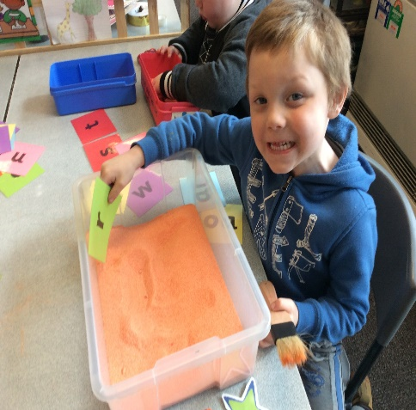

Did You Know?

Fast Fact
Children’s vocabulary and language skills begin to develop from birth. There are lots of things you can do at home to help to develop these skills.
Some ways to develop your child’s language skills at home:
- Read stories to them
- Sing songs together
- Talk to your child about their day or the things you are doing together
The Prep classroom at Karingal Heights has a comprehensive oral language program designed to continue and enhance language learning once your child starts school.

Our first Transition Day was a successful one! During this time students participated in our Early Years Investigation Time Program.
This program allows students to explore their own interests while building skills that align with curriculum standards. All students enjoyed the opportunity to move between the centres, exploring concepts and skills at their own pace.
Activities included cut and paste at the Craft Centre, musical instruments at the Music Centre, building tasks at the Construction Centre, sand exploration at the Sensory Centre, and math games at the Math Centre.
We also had some wonderful Prep and Year 1 helpers in the room to help students settle in and find their way around the classroom!
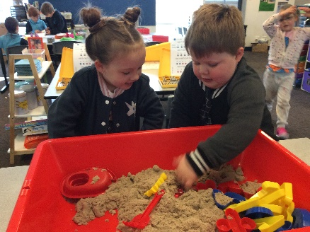
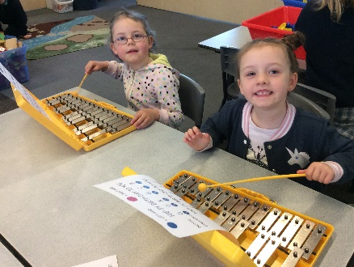

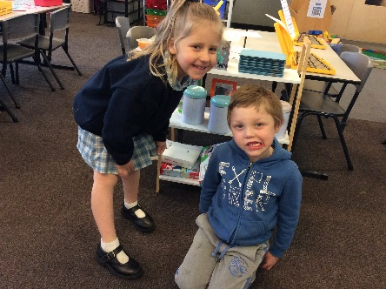
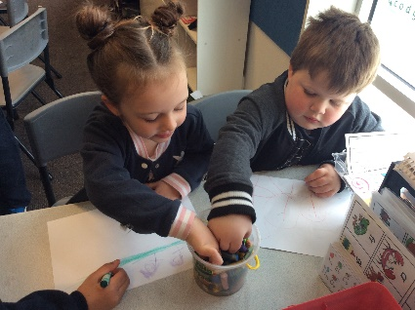
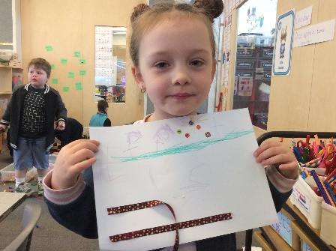
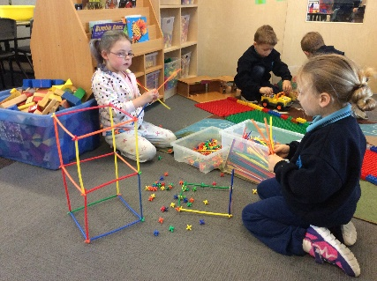

Family Involvement at Karingal Heights
Any family member is welcome to become a School Helper as long as they have a current Working with Children Check (WWCC) and it is clearly displayed at all times.
There are many ways that School Helpers can assist at the school, including:
- Changing home reader books
- Listening to students read
- Attending excursions and swimming programs
- Assisting during cooking lessons
If you have a specific skill that you would like to share (e.g. woodworking or sewing), we welcome you to come along and teach our students something new!
Working with Children Checks are required for all persons who work with children – this is a requirement of the Department of Education – and this assists us in ensuring that we maintain a safe environment for our students.
Working with Children Checks are FREE if you plan to volunteer at the school.
More information can be found at: http://www.workingwithchildren.vic.gov.au/

See you at our next Transition Session!
Thursday 12th October
9.30am – 10.30am

How Can I Help My Child?
Reading
Did you know that your child is never too young to learn to read? Children enjoy listening to stories from a very young age, even if they cannot read the book themselves. They learn by looking at the pictures and hearing the story over and over again. Eventually your child may be able to ‘read’ the words with you. Learning nursery rhymes and songs is also a way to help you child with reading. Fill your home with books, join the local library and encourage your child to read.
Fine Motor Skills
A great way to assist your child to develop their fine motor skills is to provide a variety of writing and drawing implements with which they can experiment. Thick pencils, crayons, pastels, textas and chalk along with paints that can be used with brushes or fingers will allow your child to develop a ‘feel’ for writing and drawing. Encourage your child to hold the different implements with their fingers rather than their fists as this will help with fluidity later on.

